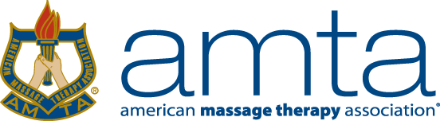

AMTA-CO Chapter Board of Directors

Candidate Application & Supporting Information

Please complete on or before March 27, 2018

Please print or type the following and send to the Online Elections Coordinator:
Application information (this page)
*Biography (maximum 300 words, see below for suggestions)
*Photo (preferably head shot taken within past year)
Sign Chapter Volunteer Code of Conduct (electronically on Chapter Page of AMTA National website)
* Biography & photo along with name and position will appear on chapter online elections page.

Please Check One:
XX 2-year term: President (2018-2020)
2-year term: Board Member (2018-2020)
2-year term: Secretary (2018-2020)
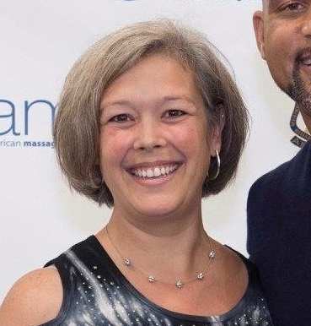
2-year term: Delegate (2018-2020)

Name: Tami Schumacher

AMTA Member ID: 185383

Address: 1260 S. Uvalda St
City: Aurora State: CO Zip: 80012
Main Phone: 303-981-4150 Other Phone: N/A

Email: tamis_spc@hotmail.com

Please check each YES box:
x YES I am a Professional Member (includes Graduate Member) in good standing.
x YES I have computer & telephone access for chapter business.
x YES I am able to commit for the entire term of office selected.
x YES I am willing and able to commit the time required for this position.
x YES I can travel for volunteer activities.
x YES I have read the position description for the position for which I am applying.

My signature below indicates that if I am elected for this office, I am able and agree to serve the term of office, that the information provided is accurate, and that permission is granted for the verification of that information.

Print Name: Tami Lee Schumacher Sign Name: Tami Lee Schumacher Date: March 13, 2018

Biography (Max 150 words): In your own words, please share why you would like to run. This can be attached separately.

Suggested topics but not limited to:
- What chapter, national, or committee positions have you held (or helped with) in the past (Include dates)?
I started volunteering with the Colorado Chapter by getting involved with the education events that were offered by the chapter and then I started asking questions about the election process and various positions that are available. I’ve been involved with the Chapter BOD/Delegates since 2012 when I first was nominated to get involved as a Delegate for the Chapter. That began my involvement with the Chapter board to become Chapter Treasurer (now Financial Administrator) and Chapter President (current position held).

- What is your vision, reason and/or objectives for becoming an AMTA-CO Chapter Team Member?
As the current President, there have been many learning curves these past 2 years and I feel I’ve just gotten to the point that I’ve come to understand my role better and be able to move forward without being unsure of the processes the Chapter and National require. I’m looking forward to continuing my role as president of the Colorado Chapter by providing a great leadership role and support to my fellow Board members and continue to provide education events at discounted rates and getting more members involved and participating in these events, especially our State Convention which we just started this April 2018. I would like to help promote more Meet & Greets throughout many area of Colorado, so ALL Massage Therapists can support each other in our industry and brainstorm with each other. I’ve been very involved with participating in all Chapter and National Events and feel I can continue to be a liaison between our Colorado Chapter and the National Office.

- What do you see yourself contributing to this position?
I feel my business management background can help with the leadership responsibilities the President Role requires. I’m very dedicated to AMTA and am always willing to go the extra mile to make sure our Chapter is operating to its fullest. I’m dedicated in making this Chapter great and making sure everyone feels welcome at all events we host.
- What are your strengths/qualifications, talents, skills and/or abilities for this position? (Include any past work experience)
I’ve been a massage therapist for the past 13 years, which helps me understand who I’m working for and with. I’m very welcoming and able to chat with everyone and make them feel comfortable. I’m hard-working and am always willing to go the extra mile for others, as well as a team player with the BOD Members and make sure the job is always completed in a timely manner. I’m dedicated to AMTA and the Colorado Chapter to make it the best we as therapists can be involved in. I have a Business Management Degree which helps with organizing, managing, facilitating and communicating with other board and chapter members. I feel I have great communication skills and ability to allow people to complete tasks that they’ve taken on for the Chapter, while being available to all BOD and Chapter members to answer questions that need answers. I also am aware of my shortcomings and am willing to always find the answers to any questions I’m not sure of the answer. I’ve been in leadership roles throughout my life that seem to have provided me with so much knowledge to continue with my leadership experience as Chapter President.

- What are your community and professional experiences? (can include your practice, education, volunteering)
AMTA-CO Delegate – 2 years 2011-2013
AMTA-CO Treasurer – 4 years 2012- 2016
AMTA-CO President – 2 year 2016-current
Member with AMTA-CO since started massage school – 2005-current
Participated in education opportunities offered by our chapter since 2009
Attended National Convention since 2011
Attended CVOP (Chapter Volunteer Orientation Program) 2013
Assisted with Chair Massage at various events throughout the chapter
Very Involved with the Government Relations Committee through the chapter, working closely with GR Rep & Lobbyist

Please contact Deb Hatch with any questions & submit this page along with biography & photo to:

Online Elections Coordinator,
Deb Hatch
handsforhealth50@msn.com
phone/text # 970-556-0277

